Practical applications: client scenarios
Now, let’s apply these techniques to specific client scenarios. You'll find four client scenarios below. Choose one scenario to discuss best practice, whether you would use the previous tasks pricing model, and your reasoning.

Scenario 1: Conservative Investor
A conservative investor is interested in stable returns with some exposure to coffee prices. They want to avoid high risks.
- Recommendation: Commodity-Linked Bonds.
  - Quantitative Implementation: Use the bond pricing model:

to determine the bond’s sensitivity to coffee price changes and set an appropriate fixed interest rate.

Scenario 2: Moderate Risk Taker
A client with a moderate risk tolerance seeks both income and exposure to coffee price movements.
- Recommendation: Structured Notes.
  - Quantitative Implementation: Define the payoff structure
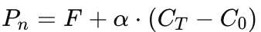
and use Monte Carlo simulations to model potential outcomes and adjust the participation rate αα.

Scenario 3: High-Risk Investor
An investor is willing to take high risks for potentially high rewards. They are specifically interested in opportunities that capitalize on significant price movements.
- Recommendation: Digital Options.
  - Quantitative Implementation: Use the binary option pricing formula to price the digital options and conduct scenario analysis to estimate the probability of different price outcomes.
Digital Call Option: The payoff is 1 if the asset's price is above the strike price at expiration.
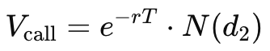

Digital Put Option: The payoff is 1 if the asset's price is below the strike price at expiration.
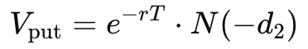

Scenario 4: Diversification Seeker
A client is looking to diversify their portfolio with an investment that provides easy access to coffee price movements.
- Recommendation: Exchange-Traded Funds (ETFs).
  - Quantitative Implementation: Optimize the ETF portfolio using an algorithm that minimizes risk and tracks coffee futures prices. Measure tracking error to ensure the ETF closely follows the benchmark.

